EXPNO 15: CREATE A SNAPSHOT OF A VM AND TEST IT BY LOADING THE
PREVIOUS VERSION/CLONED VM
DATE: 22-11-25
AIM: To create a snapshot of a vm and test it by loading the previous version/cloned vm
PROCEDURE:
STEP 1: GOTO VMWARE WORKSTATION.
STEP 2: CREATE FILES ON DESKTOP.
STEP 3: CLICK ON VM AND SELECTS SNAPSHOT-> TAKE SNAPSHOT.
STEP 4: SNAPSHOT IS BEING DONE
DESIGN: DESIGN:
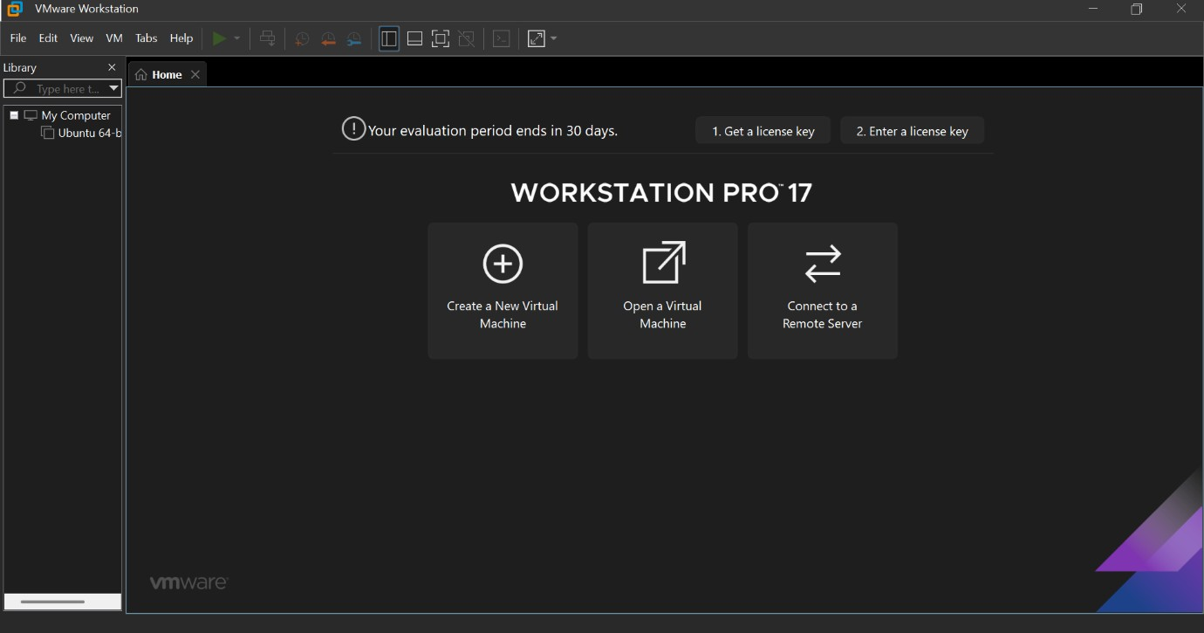
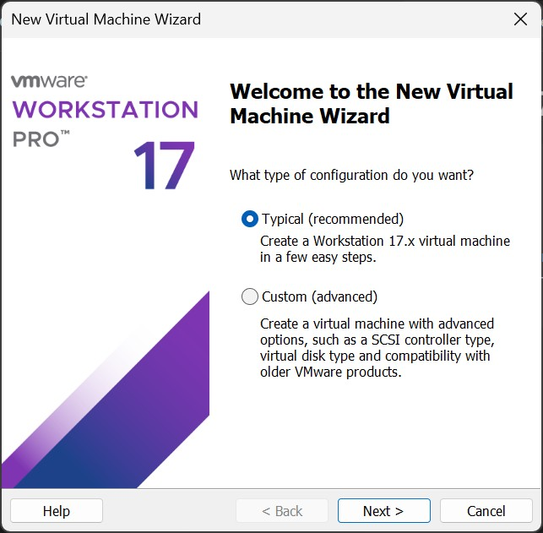

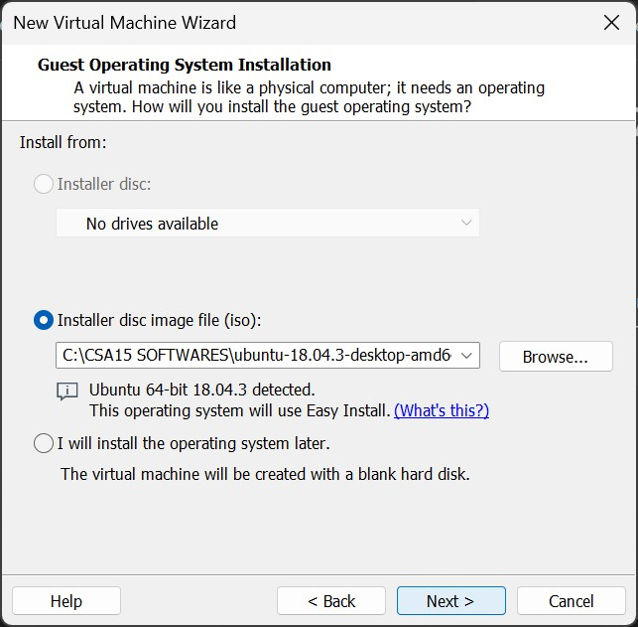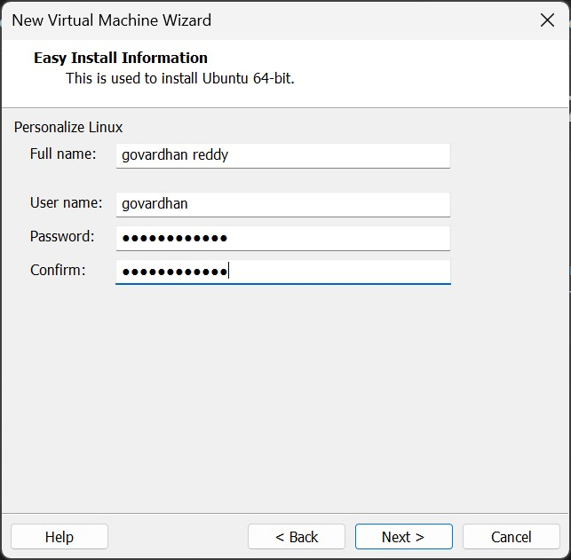

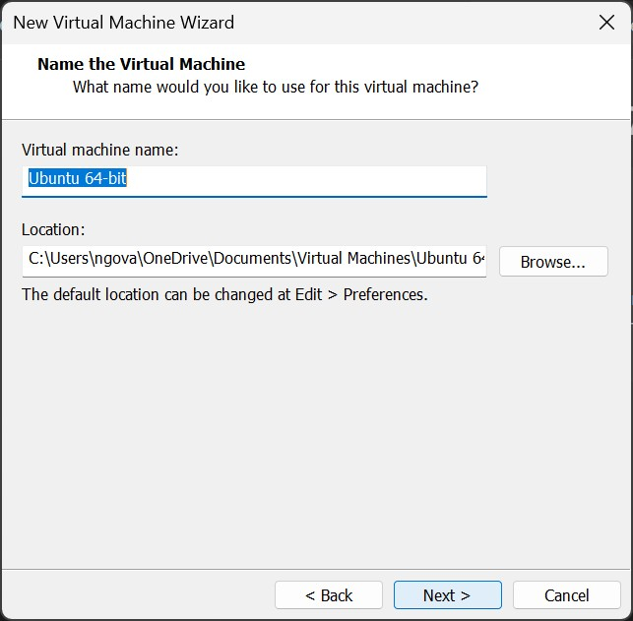

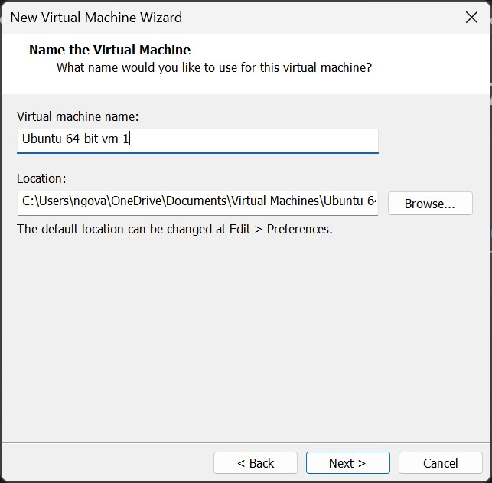

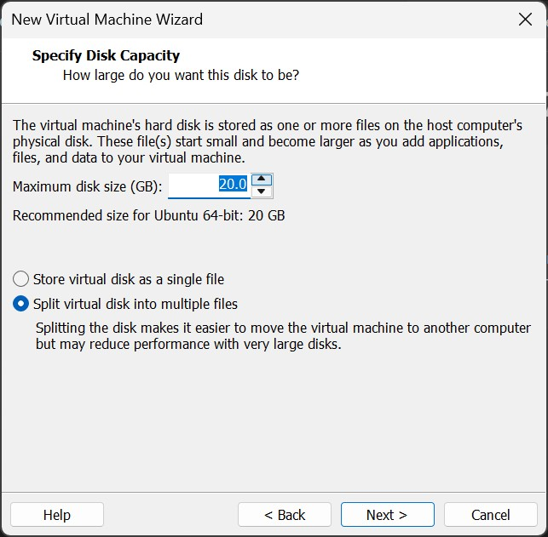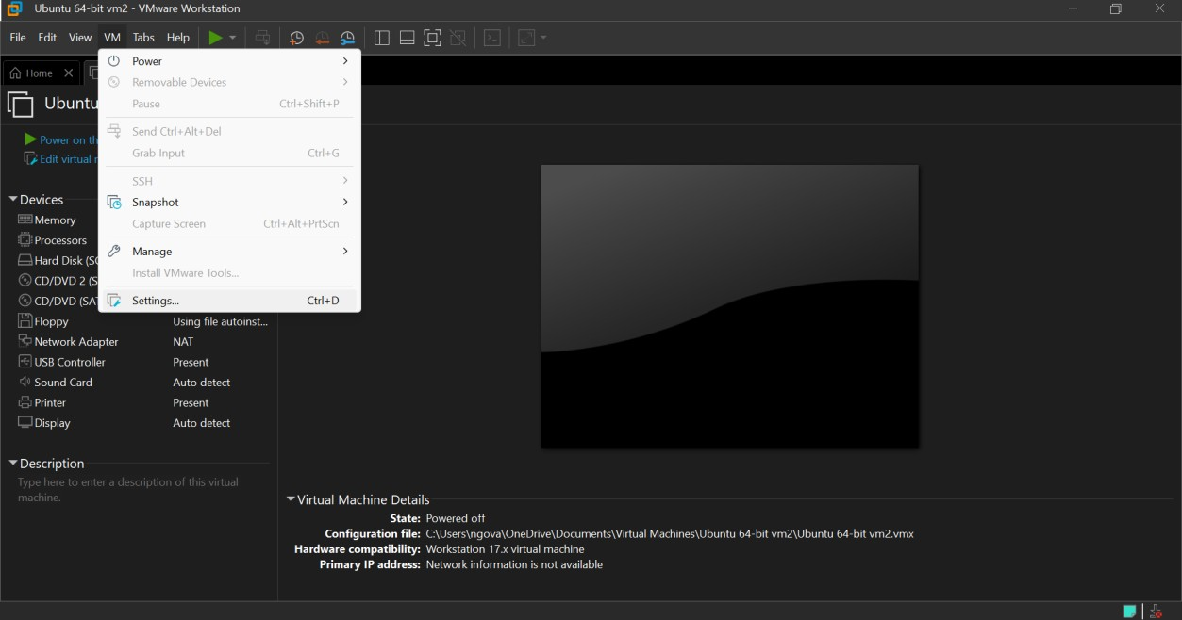

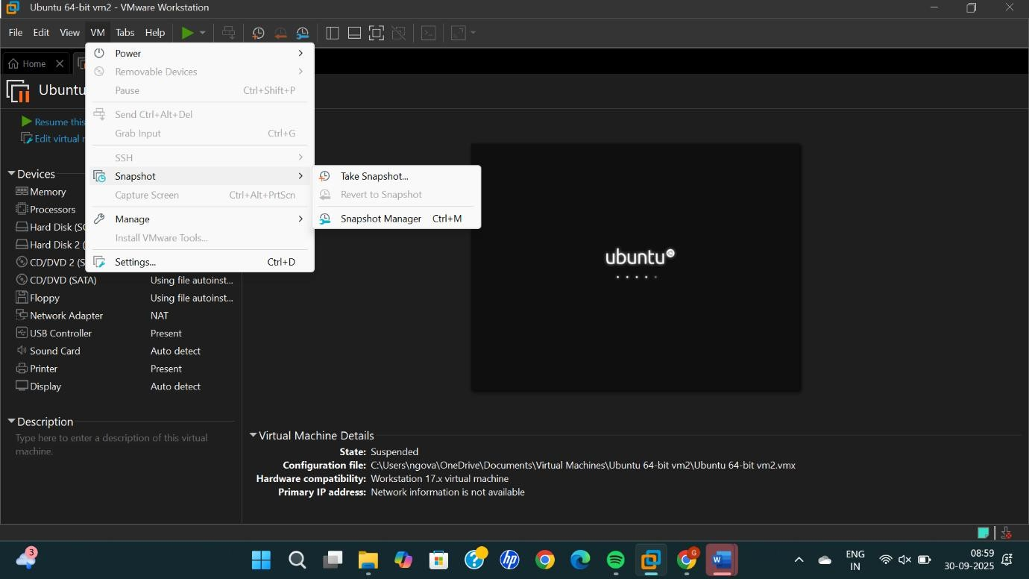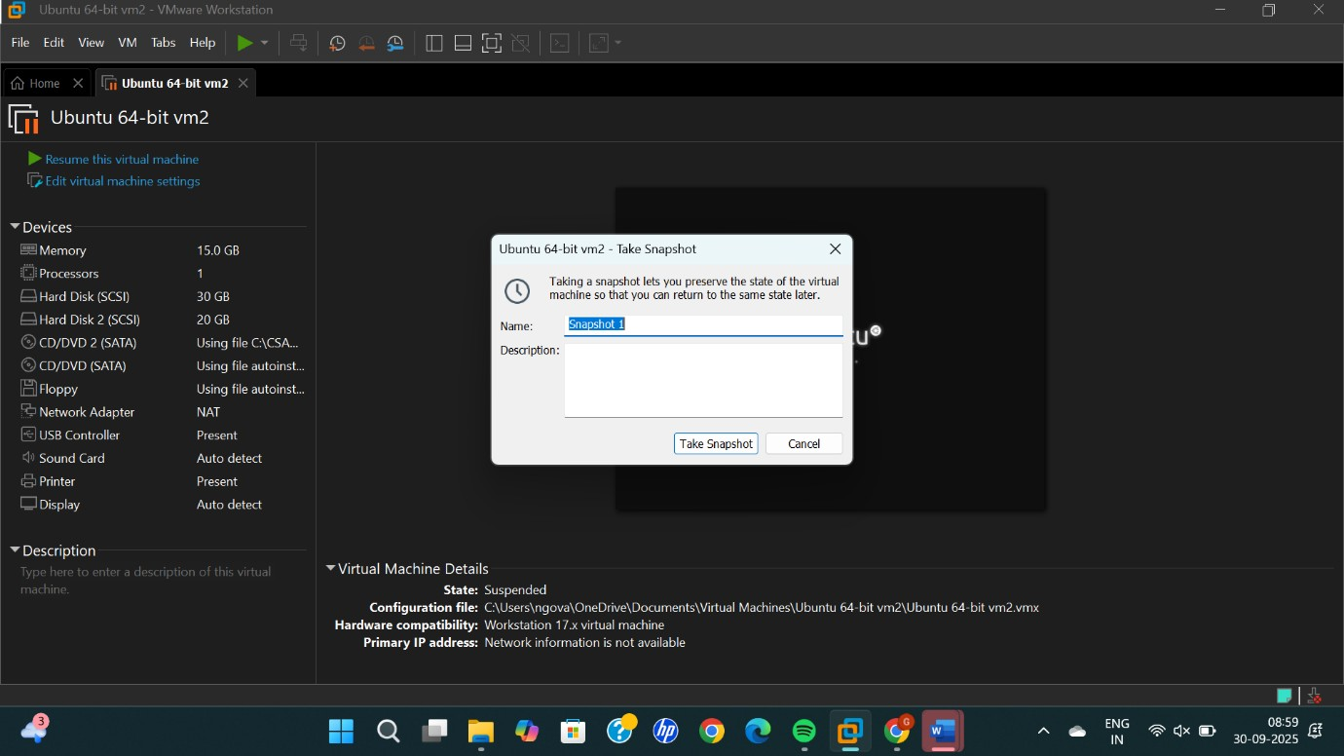

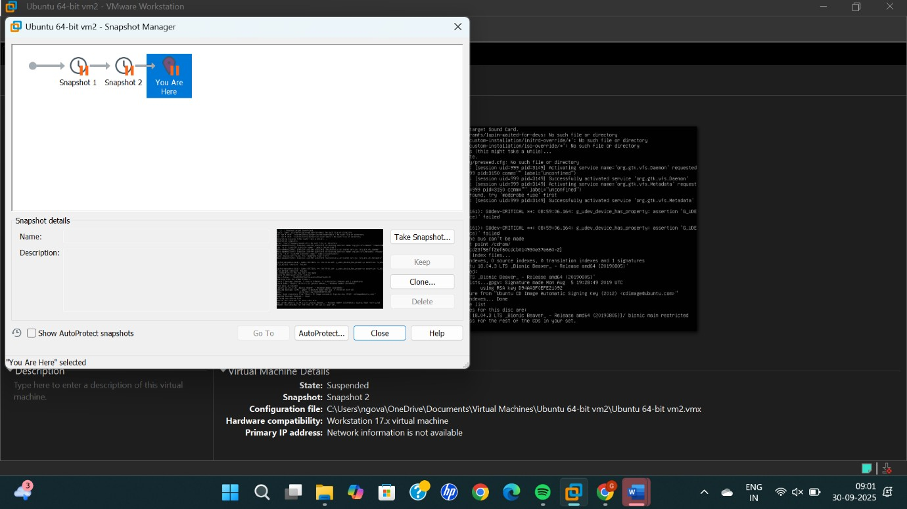

RESULT: Successfully Created A Snapshot Of A Vm And Test It By Loading The Previous Version/Cloned Vm

